WEEK 2
MODULE 6 - SPRING DATA JPA AND HIBERNET

NAME : ANANTH KARTHIK V
SUPERSET ID : 6738185

Exercise 1: Employee Management System - Overview and Setup
Given Business Scenario:
You are developing an employee management system that will manage employee data, departments, and their relationships.
Solution:
pom.xml:
<dependencies>
<!-- Spring Web -->
<dependency>
<groupId>org.springframework.boot</groupId>
<artifactId>spring-boot-starter-web</artifactId>
</dependency>
<!-- Spring Data JPA -->
<dependency>
<groupId>org.springframework.boot</groupId>
<artifactId>spring-boot-starter-data-jpa</artifactId>
</dependency>
<!-- H2 Database -->
<dependency>
<groupId>com.h2database</groupId>
<artifactId>h2</artifactId>
<scope>runtime</scope>
</dependency>
<!-- Lombok -->
<dependency>
<groupId>org.projectlombok</groupId>
<artifactId>lombok</artifactId>
<optional>true</optional>
</dependency>
<!-- Testing -->
<dependency>
<groupId>org.springframework.boot</groupId>
<artifactId>spring-boot-starter-test</artifactId>
<scope>test</scope>
</dependency>
</dependencies>
EmployeeManagementSystemApplication.java:
package com.example.demo;
import org.springframework.boot.SpringApplication;
import org.springframework.boot.autoconfigure.SpringBootApplication;
@SpringBootApplication
public class EmployeeManagementSystemApplication {
public static void main(String[] args) {
SpringApplication.run(EmployeeManagementSystemApplication.class, args);
}
}

application.properties:
spring.datasource.url=jdbc:h2:mem:testdb
spring.datasource.driverClassName=org.h2.Driver
spring.datasource.username=sa
spring.datasource.password=password
spring.jpa.database-platform=org.hibernate.dialect.H2Dialect
spring.jpa.hibernate.ddl-auto=update
spring.h2.console.enabled=true
spring.h2.console.path=/h2-console
spring.jpa.show-sql=true

Output:
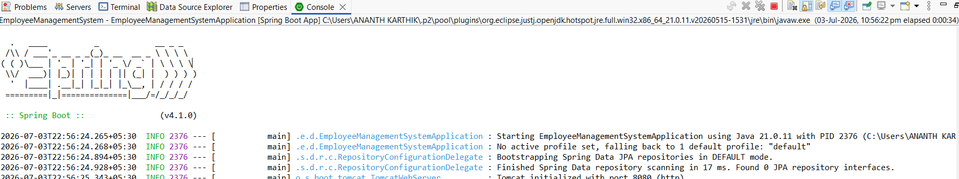

Exercise 2: Employee Management System - Creating Entities
Given Business Scenario:
Define JPA entities for Employee and Department with appropriate relationships.
Solution:
Employee.java:
package com.example.demo.entity;
import jakarta.persistence.*;
@Entity
@Table(name = "employee")
public class Employee {
@Id
@GeneratedValue(strategy = GenerationType.IDENTITY)
private Long id;
private String name;
private String email;

@ManyToOne
@JoinColumn(name = "department_id")
private Department department;
public Employee() {
}

public Employee(Long id, String name, String email, Department department) {
this.id = id;
this.name = name;
this.email = email;
this.department = department;
}

public Long getId()
return id;
}
public void setId(Long id) {
this.id = id;
}
public String getName() {
return name;
}
public void setName(String name) {
this.name = name;
}
public String getEmail() {
return email;
}
public void setEmail(String email) {
this.email = email;
}

public Department getDepartment() {
return department;
}

public void setDepartment(Department department) {
this.department = department;
}
}

Department.java:
package com.example.demo.entity;
import java.util.List;
import jakarta.persistence.*;

@Entity
@Table(name = "department")
public class Department {
@Id
@GeneratedValue(strategy = GenerationType.IDENTITY)
private Long id;
private String name;
@OneToMany(mappedBy = "department")
private List<Employee> employees;
public Department() {
}
public Department(Long id, String name, List<Employee> employees) {
this.id = id;
this.name = name;
this.employees = employees;
}
public Long getId() {
return id;
}
public void setId(Long id) {
this.id = id;
}
public String getName() {
return name;
}
public void setName(String name) {
this.name = name;
}
public List<Employee> getEmployees() {
return employees;
}
public void setEmployees(List<Employee> employees) {
this.employees = employees;
}
}

Output:
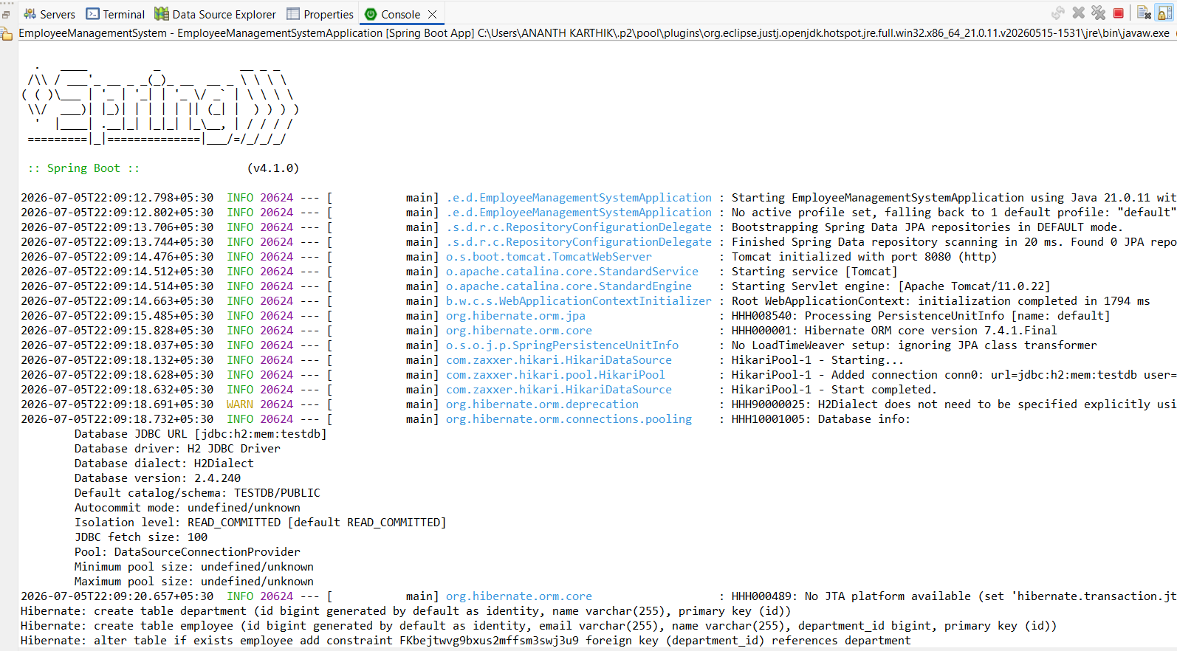
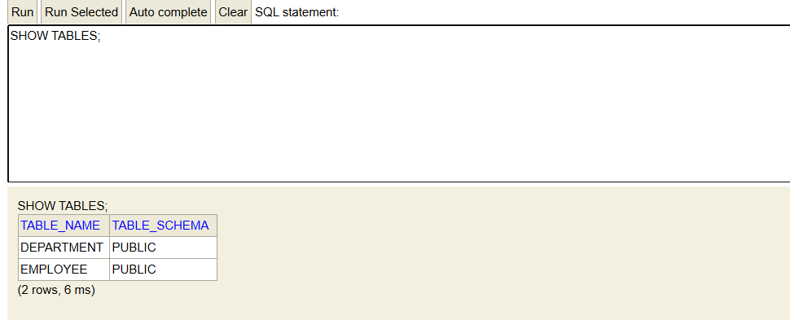

Exercise 3: Employee Management System - Creating Repositories
Given Business Scenario:
Create repositories for Employee and Department entities to perform CRUD operations.
Solution:
EmployeeRepository.java:
package com.example.demo.repository;
import java.util.List;
import org.springframework.data.jpa.repository.JpaRepository;
import com.example.demo.entity.Employee;

public interface EmployeeRepository extends JpaRepository<Employee, Long> {
List<Employee> findByName(String name);
Employee findByEmail(String email);
}

DepartmentRepository.java:
package com.example.demo.repository;
import java.util.List;
import org.springframework.data.jpa.repository.JpaRepository;
import com.example.demo.entity.Department;

public interface DepartmentRepository extends JpaRepository<Department, Long> {
List<Department> findByName(String name);
}

Output:
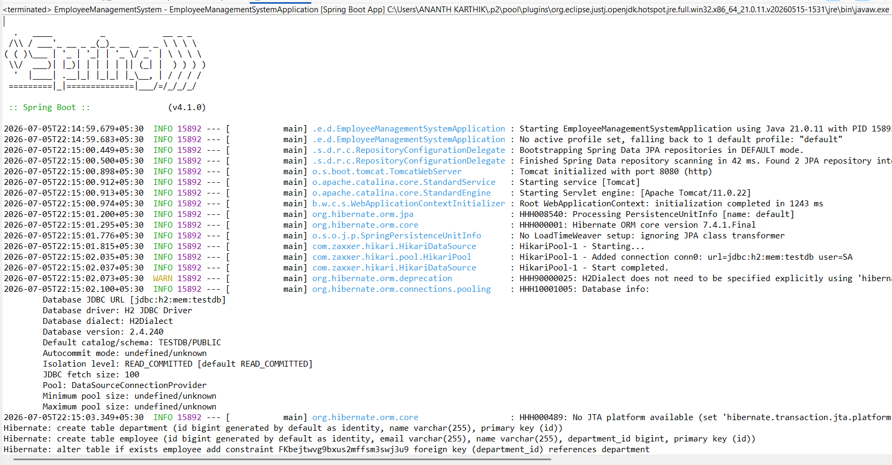

Exercise 4: Employee Management System - Implementing CRUD Operations
Given Business Scenario:
Implement CRUD operations for managing employees and departments.
Solution:
EmployeeController.java:
package com.example.demo.controller;
import java.util.List;
import org.springframework.beans.factory.annotation.Autowired;
import org.springframework.web.bind.annotation.*;
import com.example.demo.entity.Employee;
import com.example.demo.repository.EmployeeRepository;

@RestController
@RequestMapping("/employees")
public class EmployeeController {

@Autowired
private EmployeeRepository employeeRepository;

@PostMapping
public Employee createEmployee(@RequestBody Employee employee) {
return employeeRepository.save(employee);
}
@GetMapping
public List<Employee> getAllEmployees() {
return employeeRepository.findAll();
}

@GetMapping("/{id}")
public Employee getEmployeeById(@PathVariable Long id) {
return employeeRepository.findById(id).orElse(null);
}

@PutMapping("/{id}")
public Employee updateEmployee(@PathVariable Long id, @RequestBody Employee employee) {
employee.setId(id);
return employeeRepository.save(employee);
}

@DeleteMapping("/{id}")
public String deleteEmployee(@PathVariable Long id) {
employeeRepository.deleteById(id);
return "Employee deleted successfully";
}
}

DepartmentController.java:
package com.example.demo.controller;
import java.util.List;
import org.springframework.beans.factory.annotation.Autowired;
import org.springframework.web.bind.annotation.*;
import com.example.demo.entity.Department;
import com.example.demo.repository.DepartmentRepository;

@RestController
@RequestMapping("/departments")
public class DepartmentController {

@Autowired
private DepartmentRepository departmentRepository;

@PostMapping
public Department createDepartment(@RequestBody Department department) {
return departmentRepository.save(department);
}

@GetMapping
public List<Department> getAllDepartments() {
return departmentRepository.findAll();
}

@GetMapping("/{id}")
public Department getDepartmentById(@PathVariable Long id) {
return departmentRepository.findById(id).orElse(null);
}

@PutMapping("/{id}")
public Department updateDepartment(@PathVariable Long id, @RequestBody Department department) {
department.setId(id);
return departmentRepository.save(department);
}

@DeleteMapping("/{id}")
public String deleteDepartment(@PathVariable Long id) {
departmentRepository.deleteById(id);
return "Department deleted successfully";
}
}

Output:
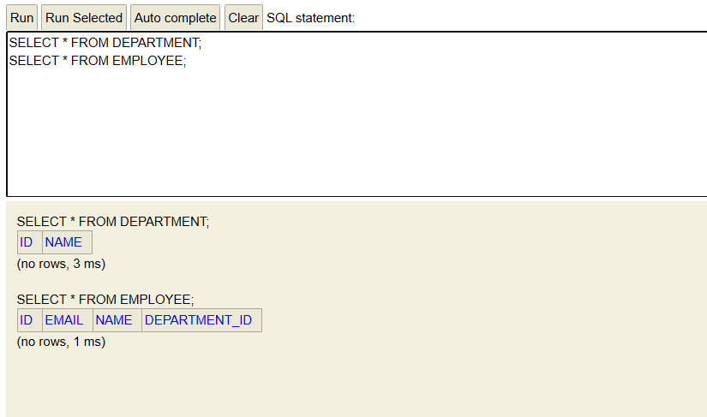

Exercise 5: Employee Management System - Defining Query Methods
Given Business Scenario:
Enhance your repository to support custom queries.
Solution:
Employee.java:
package com.example.demo.entity;
import jakarta.persistence.*;

@Entity
@Table(name = "employee")
@NamedQueries({
@NamedQuery(
name = "Employee.findByEmployeeName",
query = "SELECT e FROM Employee e WHERE e.name = :name"
),
@NamedQuery(
name = "Employee.findByEmployeeEmail",
query = "SELECT e FROM Employee e WHERE e.email = :email"
)
})
public class Employee {

@Id
@GeneratedValue(strategy = GenerationType.IDENTITY)
private Long id;

private String name;
private String email;

@ManyToOne
@JoinColumn(name = "department_id")
private Department department;

public Employee() {
}
public Employee(Long id, String name, String email, Department department) {
this.id = id;
this.name = name;
this.email = email;
this.department = department;
}

public Long getId() {
return id;
}
public void setId(Long id) {
this.id = id;

public String getName() {
return name;
}
public void setName(String name) {
this.name = name;
}
public String getEmail() {
return email;
}
public void setEmail(String email) {
this.email = email;
}
public Department getDepartment() {
return department;
}
public void setDepartment(Department department) {
this.department = department;
}
}

EmployeeRepository.java:
package com.example.demo.repository;
import java.util.List;
import org.springframework.data.jpa.repository.JpaRepository;
import org.springframework.data.jpa.repository.Query;
import org.springframework.data.repository.query.Param;
import com.example.demo.entity.Employee;

public interface EmployeeRepository extends JpaRepository<Employee, Long> {
List<Employee> findByName(String name);
Employee findByEmail(String email);
List<Employee> findByNameContaining(String name);

@Query("SELECT e FROM Employee e WHERE e.email = :email")
Employee getEmployeeByEmail(@Param("email") String email);

@Query("SELECT e FROM Employee e WHERE e.name = :name")
List<Employee> getEmployeesByName(@Param("name") String name);

@Query(name = "Employee.findByEmployeeName")
List<Employee> findEmployeeByName(@Param("name") String name);

@Query(name = "Employee.findByEmployeeEmail")
Employee findEmployeeByEmail(@Param("email") String email);
}

Output:
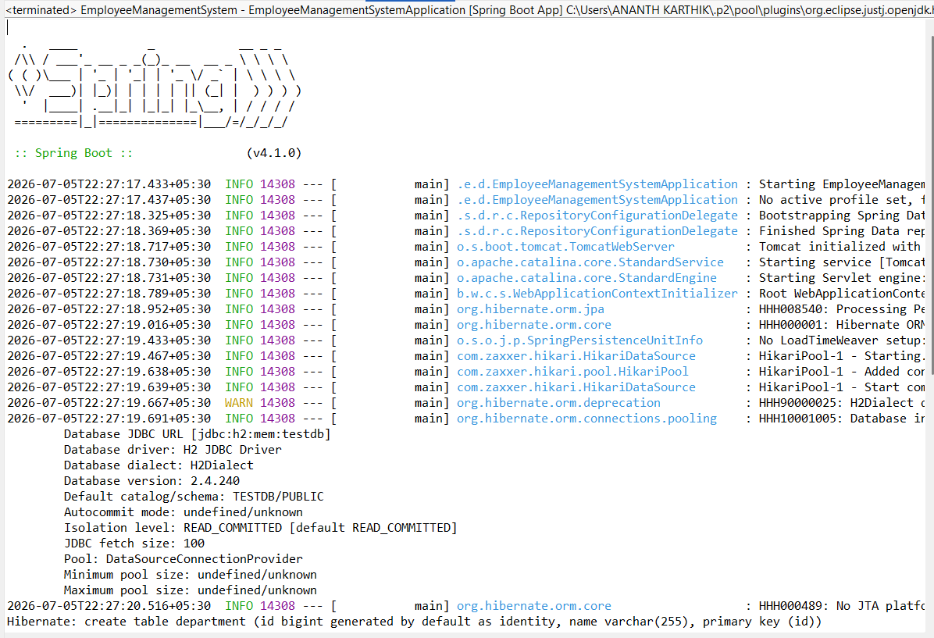

Exercise 6: Employee Management System - Implementing Pagination and Sorting
Given Business Scenario:
Add pagination and sorting capabilities to your employee search functionality.
Solution:
EmployeeRepository.java:
package com.example.demo.repository;
import org.springframework.data.jpa.repository.JpaRepository;
import com.example.demo.entity.Employee;

public interface EmployeeRepository extends JpaRepository<Employee, Long> {
}

EmployeeController.java:
package com.example.demo.controller;

import org.springframework.beans.factory.annotation.Autowired;
import org.springframework.data.domain.Page;
import org.springframework.data.domain.PageRequest;
import org.springframework.data.domain.Pageable;
import org.springframework.data.domain.Sort;
import org.springframework.web.bind.annotation.*;
import com.example.demo.entity.Employee;
import com.example.demo.repository.EmployeeRepository;

@RestController
@RequestMapping("/employees")
public class EmployeeController {

@Autowired
private EmployeeRepository employeeRepository;

@GetMapping
public Page<Employee> getEmployees(
@RequestParam(defaultValue = "0") int page,
@RequestParam(defaultValue = "5") int size,
@RequestParam(defaultValue = "id") String sortBy) {
Pageable pageable = PageRequest.of(page, size, Sort.by(sortBy));
return employeeRepository.findAll(pageable);
}
}
Output:
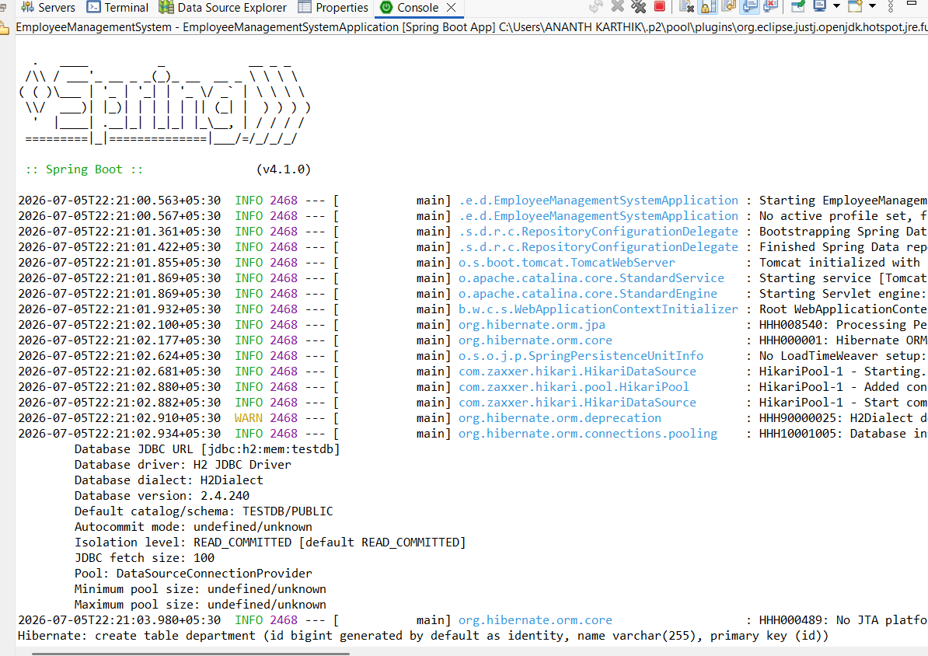

Exercise 7: Employee Management System - Enabling Entity Auditing
Given Business Scenario:
Implement auditing to track the creation and modification of employees and departments.
Solution:
AuditConfig.java:
package com.example.demo.config;
import org.springframework.context.annotation.Configuration;
import org.springframework.data.jpa.repository.config.EnableJpaAuditing;

@Configuration
@EnableJpaAuditing
public class AuditConfig {
}

Employee.java:
package com.example.demo.entity;

import java.time.LocalDateTime;
import org.springframework.data.annotation.CreatedDate;
import org.springframework.data.annotation.LastModifiedDate;
import org.springframework.data.jpa.domain.support.AuditingEntityListener;
import jakarta.persistence.*;

@Entity
@Table(name = "employee")
@EntityListeners(AuditingEntityListener.class)
public class Employee {

@Id
@GeneratedValue(strategy = GenerationType.IDENTITY)
private Long id;
private String name;
private String email;

@ManyToOne
@JoinColumn(name = "department_id")
private Department department;

@CreatedDate
private LocalDateTime createdDate;

@LastModifiedDate
private LocalDateTime lastModifiedDate;

public Employee() {
}

public Employee(Long id, String name, String email, Department department,
LocalDateTime createdDate, LocalDateTime lastModifiedDate) {
this.id = id;
this.name = name;
this.email = email;
this.department = department;
this.createdDate = createdDate;
this.lastModifiedDate = lastModifiedDate;
}
public Long getId() {
return id;
}
public void setId(Long id) {
this.id = id;

public String getName() {
return name;

public void setName(String name) {
this.name = name;
}
public String getEmail() {
return email;
}
public void setEmail(String email) {
this.email = email;
}
public Department getDepartment() {
return department;
}
public void setDepartment(Department department) {
this.department = department;
}
public LocalDateTime getCreatedDate() {
return createdDate;
}

public LocalDateTime getLastModifiedDate() {
return lastModifiedDate;
}
}

Department.java:
package com.example.demo.entity;

import java.time.LocalDateTime;
import java.util.List;
import org.springframework.data.annotation.CreatedDate;
import org.springframework.data.annotation.LastModifiedDate;
import org.springframework.data.jpa.domain.support.AuditingEntityListener;
import jakarta.persistence.*;

@Entity
@Table(name = "department")
@EntityListeners(AuditingEntityListener.class)
public class Department {

@Id
@GeneratedValue(strategy = GenerationType.IDENTITY)
private Long id;

private String name;

@OneToMany(mappedBy = "department")
private List<Employee> employees;
@CreatedDate
private LocalDateTime createdDate;
@LastModifiedDate
private LocalDateTime lastModifiedDate;

public Department() {
}
public Department(Long id, String name, List<Employee> employees,
LocalDateTime createdDate, LocalDateTime lastModifiedDate) {
this.id = id;
this.name = name;
this.employees = employees;
this.createdDate = createdDate;
this.lastModifiedDate = lastModifiedDate;
}
public Long getId() {
return id;
}
public void setId(Long id) {
this.id = id;
}
public String getName() {
return name;
}
public void setName(String name) {
this.name = name;
}

public List<Employee> getEmployees() {
return employees;
}
public void setEmployees(List<Employee> employees) {
this.employees = employees;
}
public LocalDateTime getCreatedDate() {
return createdDate;
}
public LocalDateTime getLastModifiedDate() {
return lastModifiedDate;
}
}

Output:
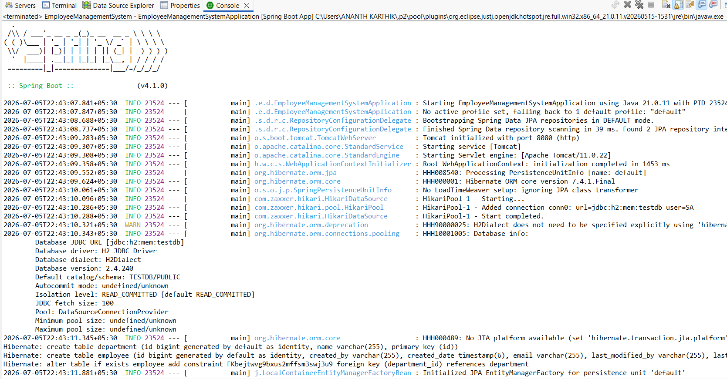

Exercise 8: Employee Management System - Creating Projections
Given Business Scenario:
Create projections to fetch specific data subsets from the employee and department entities.
Solution:
EmployeeProjection.java:
package com.example.demo.projection;
import org.springframework.beans.factory.annotation.Value;

public interface EmployeeProjection {
String getName();
@Value("#{target.email}")
String getEmployeeEmail();
}

EmployeeDTO.java:
package com.example.demo.dto;
public class EmployeeDTO {

private String name;
private String email;
public EmployeeDTO(String name, String email) {
this.name = name;
this.email = email;
}
public String getName() {
return name;
}
public String getEmail() {
return email;
}
}

EmployeeRepository.java:
package com.example.demo.repository;
import java.util.List;
import org.springframework.data.jpa.repository.JpaRepository;
import org.springframework.data.jpa.repository.Query;
import com.example.demo.dto.EmployeeDTO;
import com.example.demo.entity.Employee;
import com.example.demo.projection.EmployeeProjection;

public interface EmployeeRepository extends JpaRepository<Employee, Long> {
List<EmployeeProjection> findBy();
@Query("SELECT new com.example.demo.dto.EmployeeDTO(e.name, e.email) FROM Employee e")
List<EmployeeDTO> getEmployeeDetails();
}

Output:
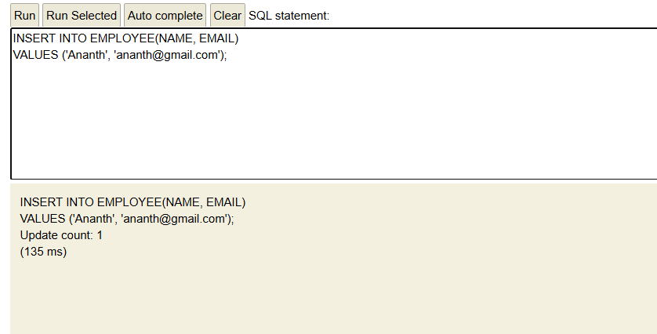
Exercise 9: Employee Management System - Customizing Data Source Configuration
Given Business Scenario:
Customize your data source configuration and manage multiple data sources.
Solution:
application.properties:
spring.datasource.url=jdbc:h2:mem:primarydb
spring.datasource.username=sa
spring.datasource.password=password
spring.datasource.driver-class-name=org.h2.Driver

spring.second-datasource.url=jdbc:h2:mem:secondarydb
spring.second-datasource.username=sa
spring.second-datasource.password=password
spring.second-datasource.driver-class-name=org.h2.Driver

spring.jpa.hibernate.ddl-auto=update
spring.jpa.show-sql=true

PrimaryDataSourceConfig.java:
package com.example.demo.config;
import javax.sql.DataSource;
import org.springframework.boot.context.properties.ConfigurationProperties;
import org.springframework.boot.jdbc.DataSourceBuilder;
import org.springframework.context.annotation.Bean;
import org.springframework.context.annotation.Configuration;
import org.springframework.context.annotation.Primary;

@Configuration
public class PrimaryDataSourceConfig {

@Primary
@Bean
@ConfigurationProperties(prefix = "spring.datasource")
public DataSource primaryDataSource() {
return DataSourceBuilder.create().build();
}
}

SecondaryDataSourceConfig.java:
package com.example.demo.config;

import javax.sql.DataSource;
import org.springframework.boot.context.properties.ConfigurationProperties;
import org.springframework.boot.jdbc.DataSourceBuilder;
import org.springframework.context.annotation.Bean;
import org.springframework.context.annotation.Configuration;

@Configuration
public class SecondaryDataSourceConfig {

@Bean
@ConfigurationProperties(prefix = "spring.second-datasource")
public DataSource secondaryDataSource() {
return DataSourceBuilder.create().build();
}
}

Output:
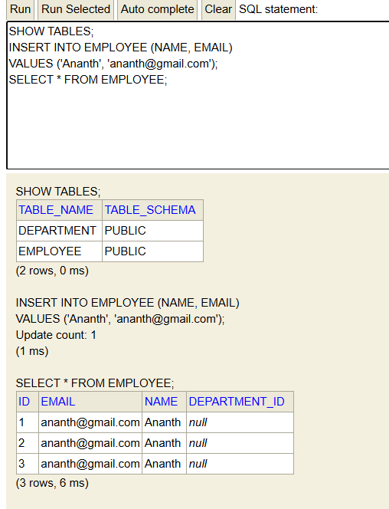

Exercise 10: Employee Management System - Hibernate-Specific Features
Given Business Scenario:
Leverage Hibernate-specific features to enhance your application's performance and capabilities.
Solution:
Employee.java:
package com.example.demo.entity;

import org.hibernate.annotations.DynamicInsert;
import org.hibernate.annotations.DynamicUpdate;
import jakarta.persistence.*;

@Entity
@Table(name = "employee")
@DynamicInsert
@DynamicUpdate
public class Employee {

@Id
@GeneratedValue(strategy = GenerationType.IDENTITY)
private Long id;

private String name;
private String email;

@ManyToOne
@JoinColumn(name = "department_id")
private Department department;

public Employee() {
}

public Employee(Long id, String name, String email, Department department) {
this.id = id;
this.name = name;
this.email = email;
this.department = department;
}
public Long getId() {
return id;
}
public void setId(Long id) {
this.id = id;
}
public String getName() {
return name;
}
public void setName(String name) {
this.name = name;
}
public String getEmail() {
return email;
}
public void setEmail(String email) {
this.email = email;
}

public Department getDepartment() {
return department;
}
public void setDepartment(Department department) {
this.department = department;
}
}

application.properties:
spring.datasource.url=jdbc:h2:mem:testdb
spring.datasource.username=sa
spring.datasource.password=password

spring.jpa.database-platform=org.hibernate.dialect.H2Dialect
spring.jpa.hibernate.ddl-auto=update

spring.jpa.properties.hibernate.jdbc.batch_size=20
spring.jpa.properties.hibernate.order_inserts=true
spring.jpa.properties.hibernate.order_updates=true

spring.jpa.show-sql=true

EmployeeService.java:
package com.example.demo.service;

import java.util.List;
import org.springframework.beans.factory.annotation.Autowired;
import org.springframework.stereotype.Service;

import com.example.demo.entity.Employee;
import com.example.demo.repository.EmployeeRepository;

@Service
public class EmployeeService {

@Autowired
private EmployeeRepository employeeRepository;

public void saveEmployees(List<Employee> employees) {
employeeRepository.saveAll(employees);
}
}

Output:
